EV CHARGING TABLEAU DASHBOARD

1. HEATMAP OF ‘ENERGY’ BY ‘DAYS OF WEEK’ AND ‘HOURS OF DAY’:

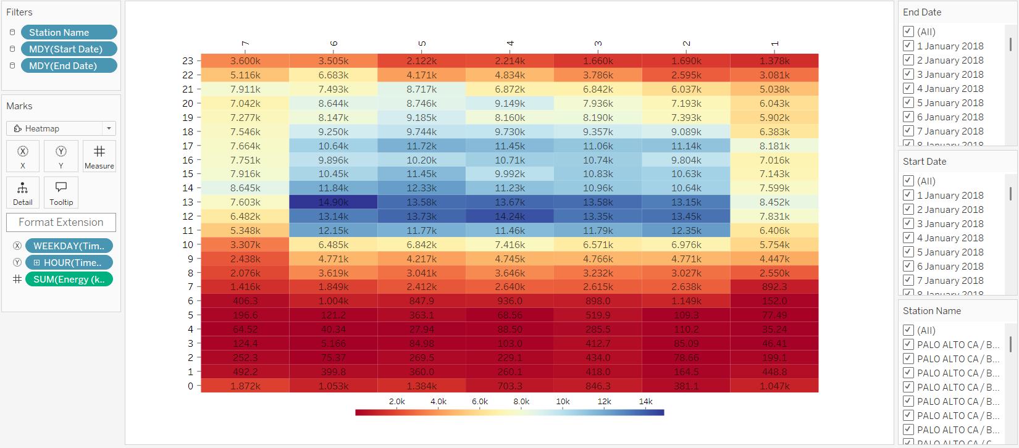

1. SCATTERPLOT OF ‘FEE’, ‘GASOLINE SAVINGS’ AND ‘STATION NAME’:

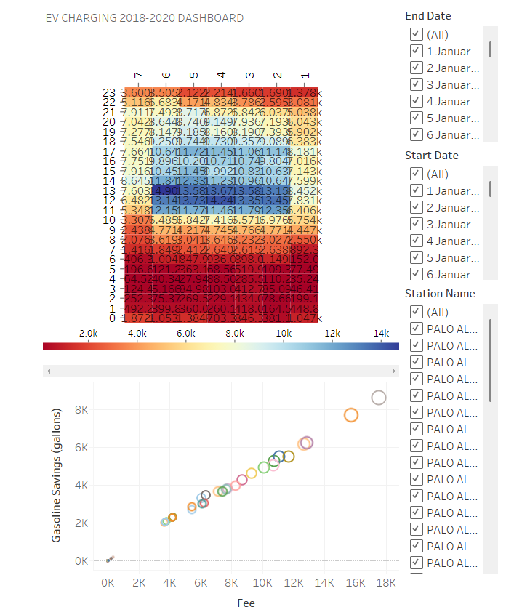

EV FORECAST TABLEAU DASHBOARD

1. LINE PLOT OF FORECASTED ‘ENERGY’ FOR THE NEXT YEAR:

